Equipment Calibration Compliance
UX Mockups and Interaction Specification
Document owner | Version | Date | Status
Michael Yaacoub, Sr Solution Engineer | 1.0 | 2026-08-24 | Draft

This template follows the sample UX pack: each SCR screen pairs a visual mockup with a specification panel, and the pack closes with a navigation-flow map.

1. Experience Overview
The primary user is a metrology technician working either at a laboratory bench with a tablet or at a machine with a handheld, entering numbers that will later be relied on by an auditor. A quality engineer works impact assessments from a desk. Design principles: the procedure leads and the technician follows, one test point at a time; tolerance results are stated in words as well as shown; as-found values are visibly locked once entered, so the integrity rule is understood rather than merely enforced; and nothing about a failure is ever hidden to keep a screen tidy.
Persona | Primary goal | Device / viewport | Usage context
Metrology technician | Complete scheduled calibrations correctly and issue the certificate from the record | Laboratory tablet, 10 inch, and shop floor handheld, 6 inch | Calibration laboratory and machine bays, gloved on the floor, intermittent coverage
Quality engineer | Understand and close the product impact when an instrument is found out of tolerance | Web, 1440 pixels and wider | Quality office, working several assessments at once

2. Screen Inventory
Screen ID | Screen name | Mapped feature | User goal | Primary action
SCR-01 | Calibration Due List | FEAT-01 | Pick the next instrument to calibrate | Start the calibration
SCR-02 | Guided Calibration Capture | FEAT-02 | Follow the procedure and record the true condition | Submit the calibration
SCR-03 | Out-of-Tolerance Impact | FEAT-03 | Find out what the failure affected | Record the dispositions
SCR-04 | Certificate and Traceability | FEAT-04 | Issue the certificate from the record | Issue the certificate

3. Screen Mockups and Specifications

3.1 SCR-01 Calibration Due List
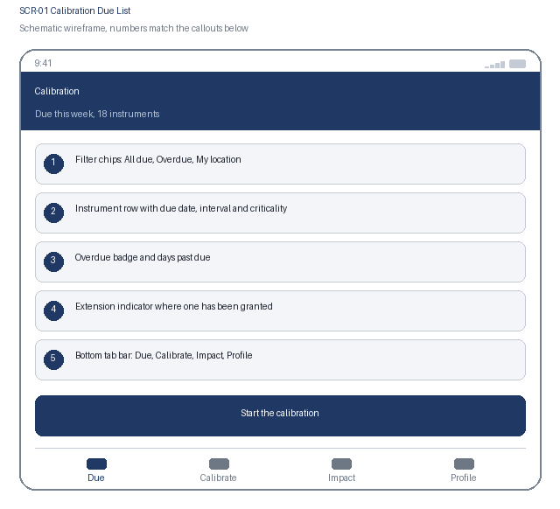  1. Filter chips: All due, Overdue, My location  2. Instrument row with due date, interval and criticality  3. Overdue badge and days past due  4. Extension indicator where one has been granted  5. Bottom tab bar: Due, Calibrate, Impact, Profile | Specification panel  Purpose: The technician sees what is due and overdue, ranked so that critical instruments are calibrated before they lapse.  Primary action: Start the calibration, which opens the approved procedure for that instrument.  Data: Instrument identifier and description, location, calibration interval, last and next due date, criticality, extension state with expiry and approver. Source: calibration service over the quality management cache.  States: Loading, due, overdue, extension granted, blocked from issue, offline  Roles: Technician sees their location; quality manager sees every site; supervisor sees issue state  Requirements: US-101, US-102, NFR-001, NFR-006

3.2 SCR-01 Interaction Details
Element / callout | Behavior | Validation | Accessibility
1. Filter chip | Filters the list in place and keeps scroll position; one chip active at a time | An empty result names the active filter and offers a route back to All due | Radio buttons in a labelled group with the selected state announced
2. Instrument row | Opens the instrument detail with its calibration history | None | One link whose accessible name combines instrument, location and days to due
3. Overdue badge | Shows days past due and persists until a passing calibration | An overdue instrument cannot be issued from the tool crib; the block states the due date | Overdue state is stated as text with the day count, never by colour alone
4. Extension indicator | Shows the expiry, justification and approver for a granted extension | An expired extension reverts the instrument to overdue immediately | The indicator names the approver and expiry in its accessible description

3.3 SCR-02 Guided Calibration Capture
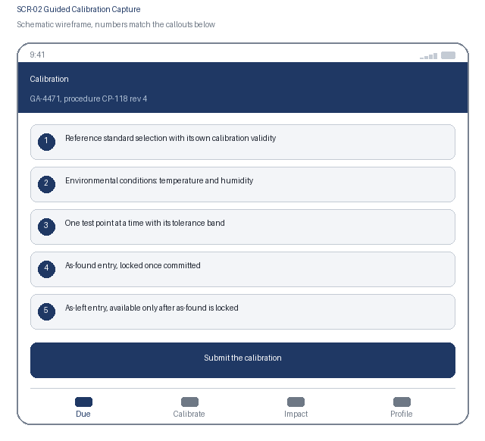  1. Reference standard selection with its own calibration validity  2. Environmental conditions: temperature and humidity  3. One test point at a time with its tolerance band  4. As-found entry, locked once committed  5. As-left entry, available only after as-found is locked | Specification panel  Purpose: The technician works through the approved procedure point by point, recording the as-found condition before any adjustment is made.  Primary action: Submit the calibration, which evaluates every point and issues a pass or fail outcome.  Data: Procedure identifier and revision, reference standard with certificate number and validity, environmental readings, test points with nominal value and tolerance, as-found and as-left values. Source: calibration service.  States: Standard invalid, in progress, as-found locked, adjusting, submitted, passed, failed  Roles: Technician captures; quality engineer reads; nobody edits an as-found value  Requirements: US-201, US-202, NFR-003, NFR-006

3.4 SCR-02 Interaction Details
Element / callout | Behavior | Validation | Accessibility
1. Standard selector | Lists eligible reference standards with their calibration validity | A standard out of calibration cannot be selected, and the reason is stated on the option itself | Each option's accessible name includes the standard and its validity state
2. Test point entry | One point fills the screen; committing advances to the next point | Value must be numeric and within the instrument's measuring range; the tolerance result is shown immediately as in or out of tolerance | The result is announced assertively as text, never conveyed by colour alone
3. As-found lock | Committing an as-found value locks it and reveals the as-left field | A locked value cannot be edited; a mistaken entry requires the calibration to be voided and restarted, with the reason recorded | The lock is stated in text next to the value, and the consequence is explained before commit
4. Submit the calibration | Evaluates all points and sets the overall outcome | Blocked while any test point is incomplete, with the outstanding points listed | A failing outcome is announced assertively and cannot be dismissed without acknowledgement

3.5 SCR-03 Out-of-Tolerance Impact
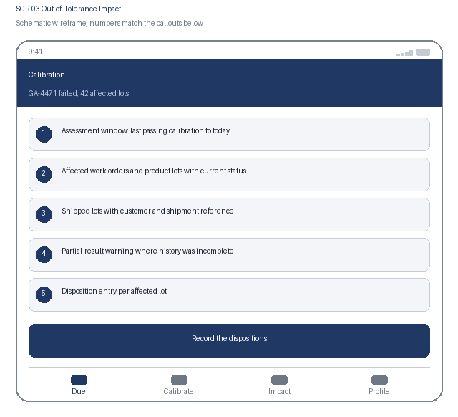  1. Assessment window: last passing calibration to today  2. Affected work orders and product lots with current status  3. Shipped lots with customer and shipment reference  4. Partial-result warning where history was incomplete  5. Disposition entry per affected lot | Specification panel  Purpose: When an instrument fails, the engineer sees exactly which product was measured with it and records a decision for each affected lot.  Primary action: Record the dispositions, which closes the assessment and unblocks certificate issue.  Data: Assessment window dates, affected measurement records, work orders and lots with status, shipped lot customer and shipment reference, disposition and justification per lot. Source: impact assessment engine over measurement history.  States: Assessing, complete, partial and labelled incomplete, dispositioning, closed  Roles: Quality engineer dispositions; quality manager approves; technician reads  Requirements: US-301, US-302, NFR-001, NFR-006, NFR-007

3.6 SCR-03 Interaction Details
Element / callout | Behavior | Validation | Accessibility
1. Assessment window | States the exact date range covered and the record count examined | None | The window and count are announced on load so the scope is never assumed
2. Partial-result warning | Appears whenever the measurement history query did not cover the full window | Certificate issue stays blocked while the warning is present | Announced assertively, because acting on a partial list is the risk this prevents
3. Lot row | Expands to show the measurement, work order, date and operator | None | Disclosure with expanded state announced; status stated as text
4. Disposition entry | Records a decision and justification for each affected lot | Justification mandatory, minimum 20 characters; the assessment cannot close while any lot is undispositioned, and the outstanding lots are listed | Outstanding lots are listed as text rather than implied by a disabled control

3.7 SCR-04 Certificate and Traceability
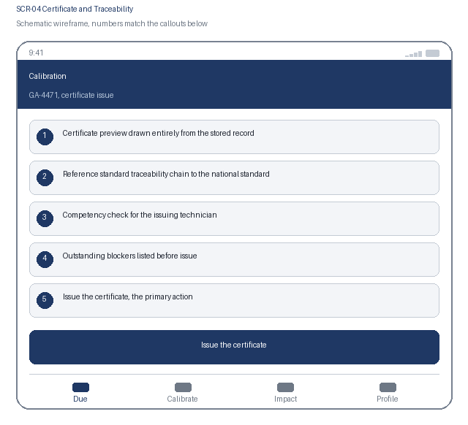  1. Certificate preview drawn entirely from the stored record  2. Reference standard traceability chain to the national standard  3. Competency check for the issuing technician  4. Outstanding blockers listed before issue  5. Issue the certificate, the primary action | Specification panel  Purpose: The certificate is generated from the captured readings, carries the traceability chain, and can only be issued by a competent named person.  Primary action: Issue the certificate, which writes the immutable certificate and updates the next due date.  Data: Every test point with as-found, as-left, tolerance and outcome, environmental conditions, reference standard with certificate number and traceability chain, issuing technician and competency, next due date. Source: calibration service and certificate generator.  States: Blocked by an open impact assessment, blocked by competency, ready to issue, issued and read-only, superseded  Roles: Technicians holding the calibration competency issue; auditor reads the issued certificate  Requirements: US-401, US-402, NFR-004, NFR-006

3.8 SCR-04 Interaction Details
Element / callout | Behavior | Validation | Accessibility
1. Certificate preview | Renders from the stored record with no editable field | No value can be typed or overridden here; a wrong value requires the calibration to be voided | The read-only nature is stated in text, not implied by the absence of inputs
2. Traceability chain | Expands to show each standard in the chain to the national standard | An incomplete chain blocks issue and names the missing link | Disclosure with expanded state announced; the chain reads as an ordered list
3. Competency check | Evaluated server side when the screen opens | Issue is blocked without the competency for this instrument class, and the required competency is named | The block explains what is missing rather than returning a permission error
4. Issue the certificate | Writes the certificate, locks the record and sets the next due date | Blocked while any impact lot is undispositioned or the chain is incomplete, with each blocker listed | Confirmation states plainly that an issued certificate can only be superseded, never edited

4. Navigation Flow
From | User action / condition | To | Alternate or error path
SCR-01 | Technician starts a scheduled calibration | SCR-02 | Instrument already in calibration by another technician: the row refreshes and names the holder
SCR-02 | Calibration submitted with an as-found failure | SCR-03 | Calibration passes: skip to SCR-04 for certificate issue
SCR-03 | Every affected lot dispositioned | SCR-04 | Measurement history incomplete: the partial warning persists and certificate issue stays blocked
SCR-04 | Competent technician issues the certificate | SCR-01, with the next due date set | Competency missing or the traceability chain incomplete: issue is blocked with the reason stated
Flow: SCR-01 Calibration Due List, start calibration, to SCR-02 Guided Calibration Capture, submit, to SCR-03 Out-of-Tolerance Impact, disposition, to SCR-04 Certificate and Traceability, issue, and back to SCR-01. A passing calibration skips SCR-03 and moves straight to certificate issue, and the bottom tab bar reaches Due, Calibrate, Impact and Profile.

5. Responsive Behavior
Viewport | Navigation | Layout | Content priority | Interaction changes
Phone | Bottom tab bar with four primary destinations | Single column, cards stacked in priority order | Due date, instrument and criticality first; supporting detail below | One-handed reach at the machine with numeric entry sized for gloves; no swipe-only path
Tablet | Adaptive left navigation rail | Due list beside the selected instrument's calibration detail | Primary list beside the selected item's detail panel | Touch and pointer both supported; hover reveals nothing essential
Web | Persistent left navigation with breadcrumbs | Due register, capture detail and impact list in three columns | Dense scanning of many records, with full detail on selection | Full keyboard support with shortcuts for commit and issue; no hover-only affordance

6. States and Content
State | Trigger | Displayed content | Available actions
Loading | A data request is still in flight after 300 ms | Skeleton rows preserving the final layout; the impact assessment shows its progress through the window | Cancel and retry remain available
Empty | A filter, search or assignment returns no records | A plain statement that no instruments match, naming the active filter | Clear the filter, or switch to All due
Error | A request fails, times out, or is rejected by policy | What failed and whether any captured reading was affected, which is stated first | Retry; captured readings are always preserved locally
Offline | The device loses network connectivity | A persistent offline banner and a count of calibrations waiting to submit | Capture continues; certificate issue queues and completes after sync

7. Accessibility Requirements
- WCAG 2.2 AA is the conformance target for every screen, including all interactive states and error messaging.
- Every control is reachable in a logical tab order with a visible focus indicator, a programmatic label, and instructions announced before the input rather than only after an error.
- Errors are announced through an assertive live region, name the field, and describe how to correct the problem.
- Text contrast is at least 4.5 to 1 and non-text indicators at least 3 to 1; the interface remains usable at 200 percent text resize and at 320 CSS pixels wide.
- Motion is limited and honours the reduced-motion preference; no information is conveyed by colour alone.
- Touch targets are at least 44 by 44 CSS pixels with adequate spacing, so the interface stays usable with gloves or one hand.
- {Keyboard order, visible focus, labels, instructions, and error announcement behavior}
- {Contrast, text resize, reduced motion, screen-reader, and touch-target expectations}

8. Review and Approval
Reviewer | Role | Decision | Comments | Date
Design lead | UX design authority | Pending | Interaction model and visual specification
Accessibility specialist | Accessibility | Pending | WCAG 2.2 AA conformance evidence
Product owner | Business product owner | Pending | Screen inventory and flow confirmation

